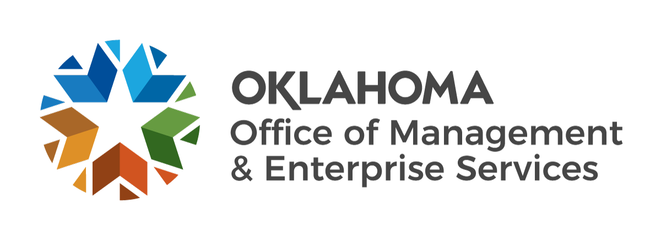 | Request for In-state GSA Rate Lodging Exception

MUST SUBMIT IN ADVANCE OF TRAVEL
When completed, please email the form to: omestptravel@omes.ok.gov.

1. State entity name/number:
2. Name, address and daily rate of hotel in which you are requesting to stay:

3. Requestor's telephone: Requestor’s email:
- State entity travel arranger:
- State entity travel arranger phone number:
- Describe efforts made to obtain lodging at the GSA rate:
(If necessary, attach additional page, to provide justification.)

- Alternatives researched and comparison of rate and cost:
- Please specify the time period for which you are requesting the exception.
Exception period requested from , 20 to , 20

The undersigned, duly authorized to sign on behalf of the state entity named herein, for the purpose of requesting an exception to the State Lodging Procedures, does hereby affirm that the requested exception is necessary. Further, in the event this exception is approved, I understand it does not relieve said state entity of its legal responsibility to comply with all applicable laws and administrative rules. 74 O.S. 500.9 provides for overnight lodging, while on official travel status within the state, at a rate of up to 150% of the amount authorized by the GSA under the provisions of the Internal Revenue Code of 1986, if it is determined that no lodging is available at the current maximum rate.

Signature of requestor Date

ATTACH THIS COMPLETED FORM TO THE TRAVEL VOUCHER OR P-CARD RECEIPT
This request is hereby: | Approved | Denied |  | for the period of: |  | to

Comment:
State Travel Office |  |  |  | Date

